p50
p50 is the pO₂ at which saturation of haemoglobin is 50% (sO₂ = 50%)
The p50 reported by the blood gas analyser is a calculated result.
By standardising p50 to pH = 7.4, pCO₂ = 5.3 kPa and 37 ^{O} C (= p50st) the only remaining causes of a shifted p50 would be a variant haemoglobin with abnormal O₂ affinity or abnormal 2.3 DPG (or 2,3 BPG).
p50 reflects “in vivo” p50, which is important for oxygen delivery to tissue.
A venous blood gas sample should be used. The calculation for p50 becomes unreliable when oxygen saturation is >97% (at high pO₂ the ODC is flat and factors affecting oxygen saturation have little effect on the shape of the curve), making arterial samples less accurate. Capillary samples have been reported as unsuitable.
Example of ODC (1):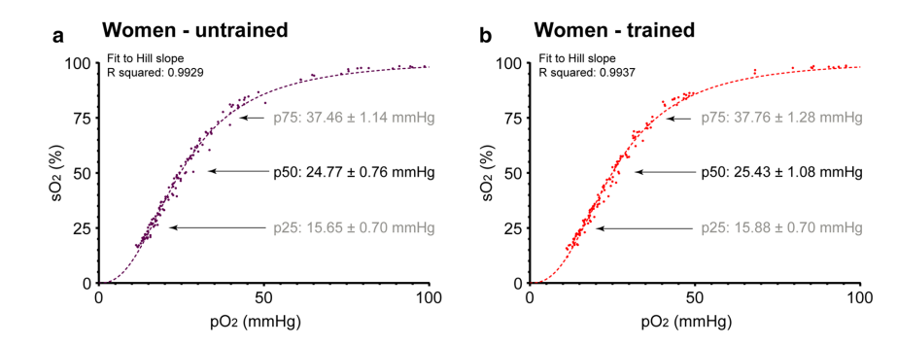
Indications for measuring p50:
- Unexplained polycythaemia, looking for a high affinity haemoglobin variant (a low p50)
- Unexplained cyanosis with or without anaemia (high p50)
- Investigating the cause of a discrepancy between pO₂ and SpO₂ or sO₂
Decreased p50 Increased p50
- Acute alkalosis Acute acidosis
- Hypocapnia Hypercapnia
- Hypothermia Fever
- High affinity haemoglobin variant Low affinity haemoglobin variant
- Presence of fetal haemoglobin Sepsis
- COHb, MetHb
- Inherited deficiency of 2,3 DPG
Abreviations:
ODC = oxygen dissociation curve, pO₂ = partial pressure of O₂
sO₂ = saturation of functional Hb (blood gas). SpO₂ = saturation by pulse oximetry
References
- A broad diversity in oxygen affinity to haemoglobin. Björn Balcerek et al. Scientific Reports volume 10, Article number: 16920 (2020)
- How we diagnose and manage altered oxygen affinity hemoglobin variants. Jovana Yudin,Madeleine Verhovsek. Am J Hematol. 2019;94:597–603.

